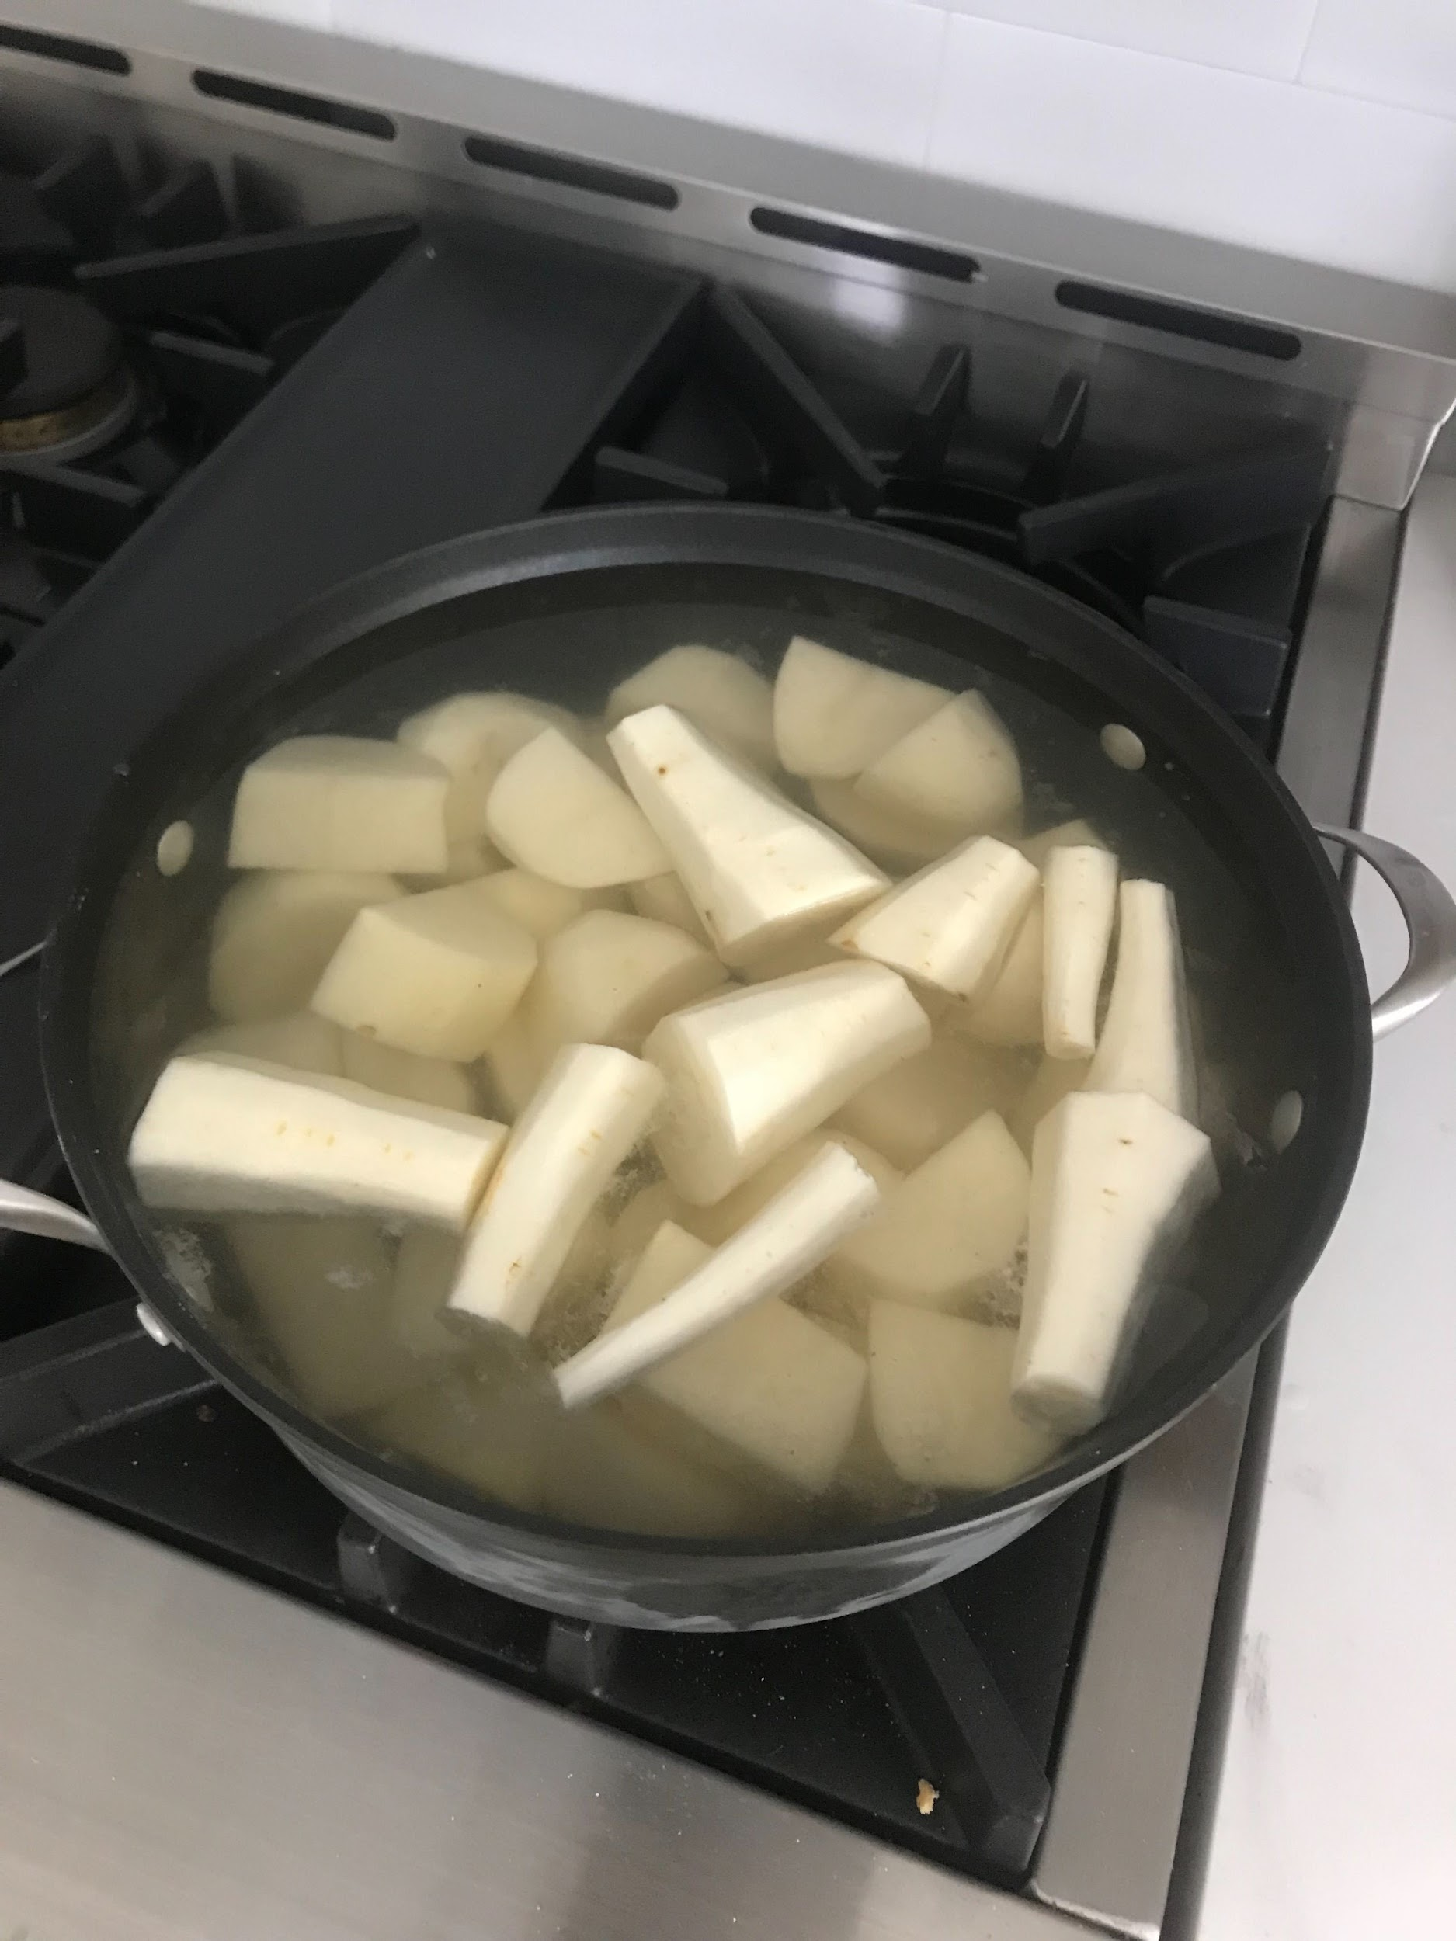
Roast potatoes first and foremost. I use russets because you can rarely get maris pipers here. Always always start them in cold heavily salted water and cook them at a simmer for 10-15 mins. Drain them off until they’re completely dry. You can also cook off any extra water that’s on the potatoes. Shake them up and let them cool completely. Have a hot sheet pan with olive oil slicking the bottom in the oven ready, then chuck in the potatoes, toss with sea salt, and roast until awesome -- 20 min?

If they aren’t fluffy like this before they go in the oven you’ll have shit roast potatoes

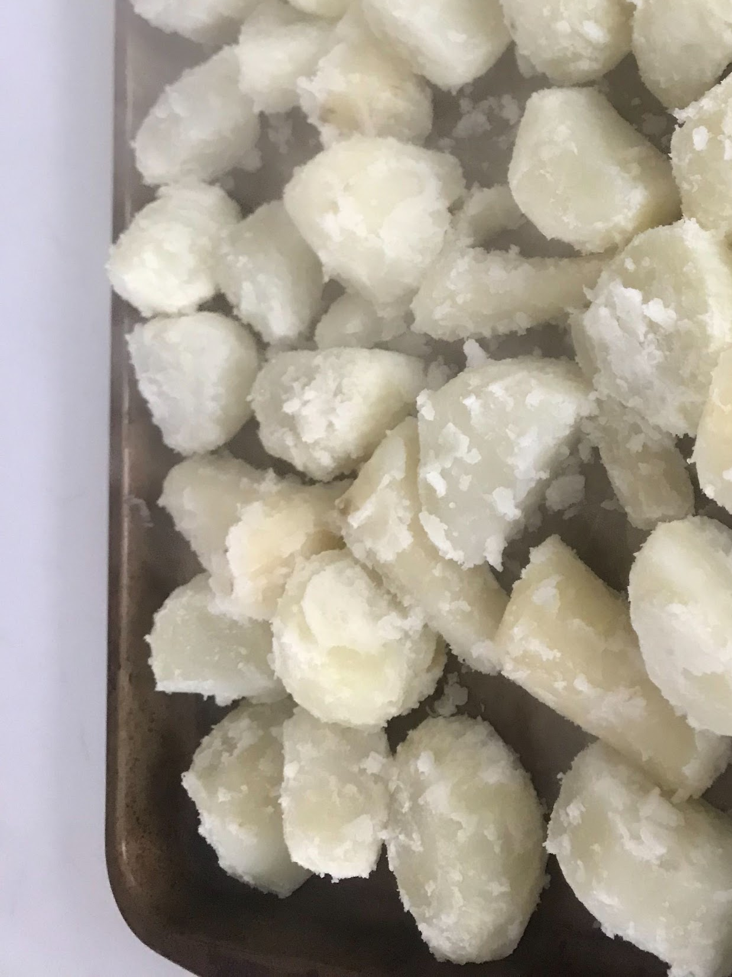
Make herb compound butter, always, if you just have spare shallot and some herbs. Then you can stuff it under the skin on your roast chicken to keep the breasts from drying out
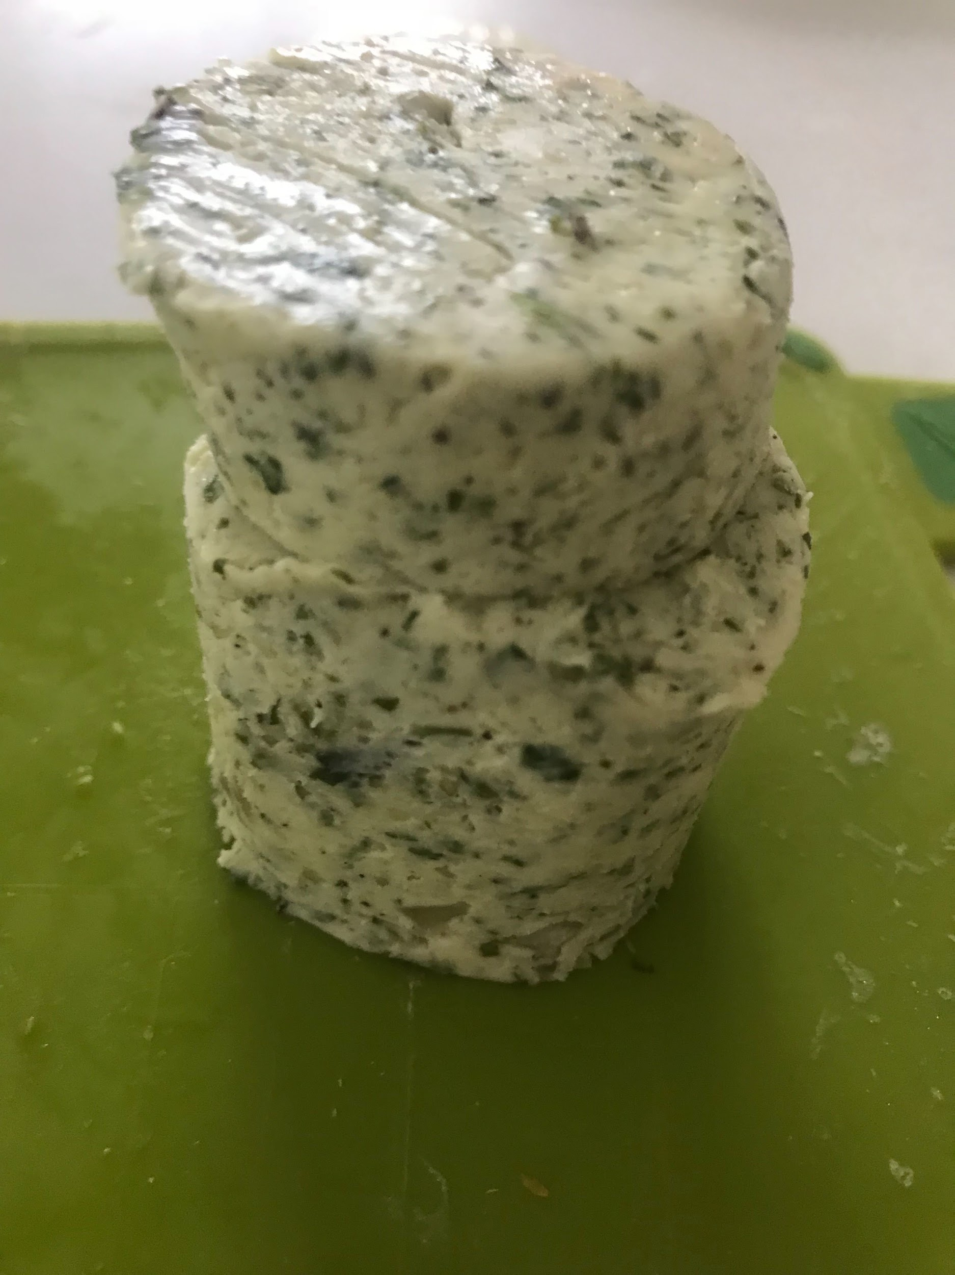
I make a bed of leftovers for the chicken to sit on, that’s gonna be the base for your gravy, and always make some sort of sausage stuffing, because it makes the gravy extra delicious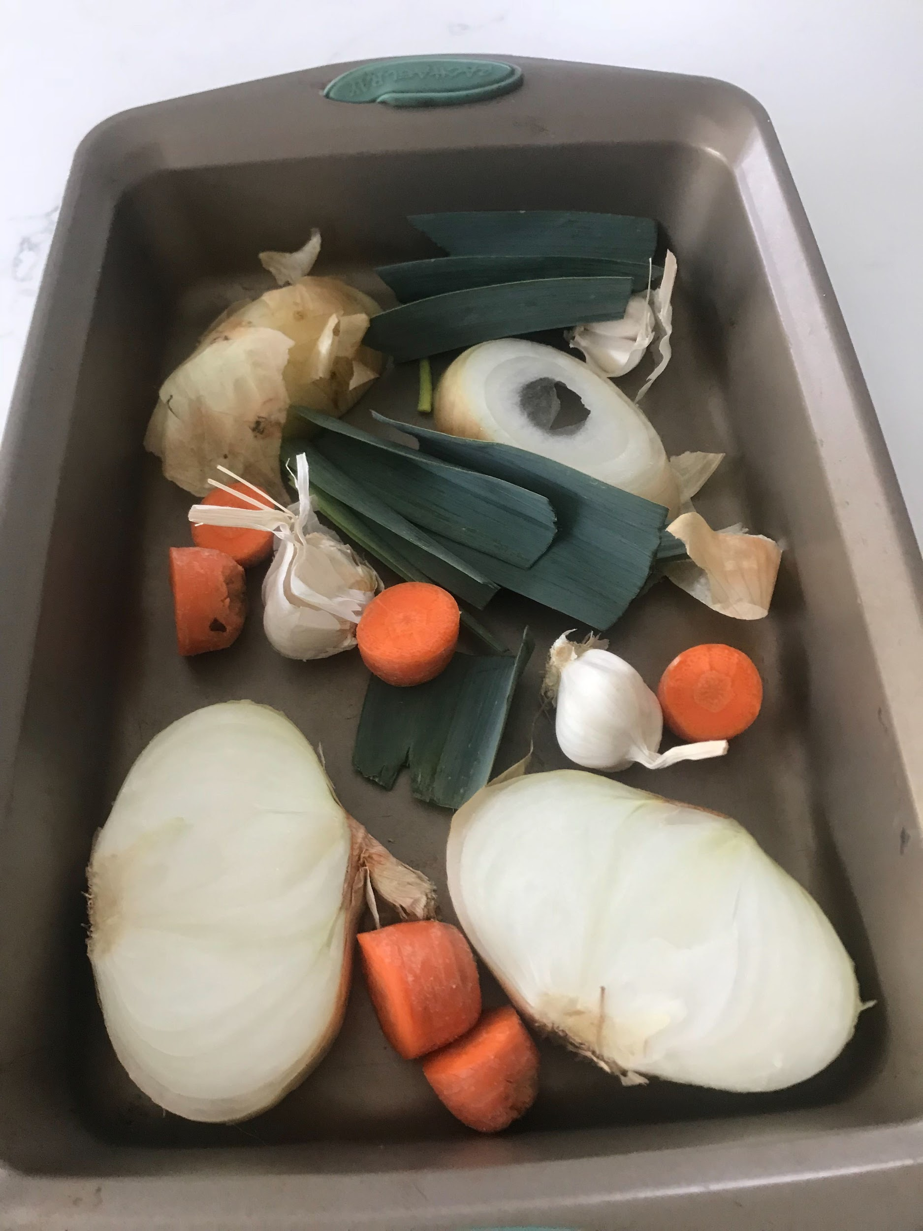

20 minutes per pound at 375, plus 20 minutes then leave time for it to rest for 30 minutes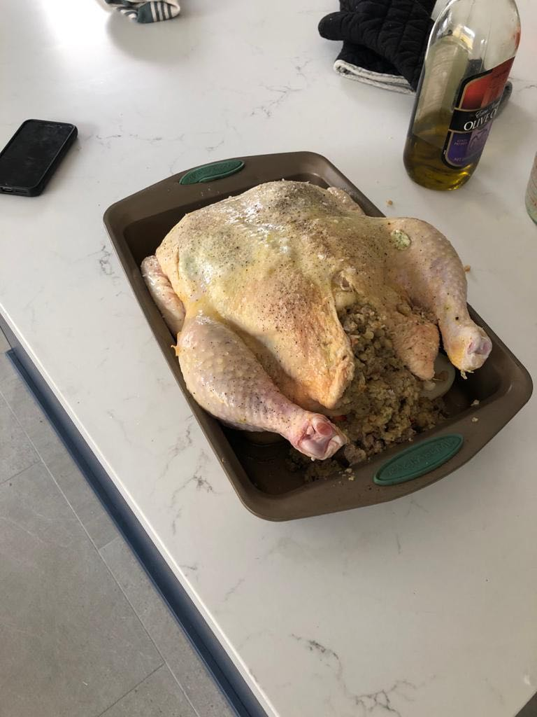
Also make sure you pat down the chicken with paper towels and dry off the skin completely before you oil and season it

Drain off the juice
Put it in that jug thing in the fridge to separate

Chuck your pan directly on the stove

Deglaze with white wine or red wine or beer depending on what you’re making

Mash the fuck out of it as it reduces
Always keep it simmering never boiling

When it’s reduced right down you can either add flour (make sure to cook it off) or bisto

Then gradually add your leftover water from boiling veggies

Whisk in and let it reduce again

You can also add Demi glace to make it more intense

Other things I like to add are red currant jelly, or balsamic vinegar then reducing it down more

You don’t really have to skim

Chuck it through a strainer, add more veg water then reduce to consistency again (never boiling)

You can also mount it with butter which is just whisking in a lump of cold butter at the end to make it super decadent

If it’s not as thick as you want you can add “beurre manie” which is where you mush together a ball of equal parts room temp butter and flour and whisk it in



